

**ADDIS ABABA SCIENCE AND TECHNOLOGY UNIVERSITY**

**Integrated Engineering Team Project**

**Mini water purifier container Proposal**

Group Members ID No.

1. Melat Zenebe ……………………………………..ets0826/13
2. Nigussie Negash …………………….….................ets1061/13
3. Eyosafet Alem …………………………..………...ets0474/13
4. Yemiserach Gashaw …………………………...….ets1310/13
5. Immanuel Samson ………………………………...ets0649/13
6. Yidinekachew Birhanu ……………………………ets1313/13
7. Kennake Bekele……………………………………ets1469/13
8. Hana Kebede ………………………………………ets0586/13
9. Zereyakob Melaku ………………………………...ets1403/13

**Advisor: Mr. Felix Edesa**

***TABLE OF CONTENT***

1.0 Introduction………………………………………….…………………………………..2

1.1 Background……………….…………………………….………………………………..2

1.2 Problem statement……………………………………………………………………......3

1.3 Obje ctive…………………………………………………………………………………4

1.4 Solution……………………………………………………………….…………………..5

1.5.Task/Work allocation………………………………………………….…………………5

1. 6 Budget allocation ………………………………………………………………………..6

1.7 Project flow showing………………………………………………….………………….7

1.8 Conclusion…………………………………………………………….…………………8

Reference………………………………………………………………….…………………9

## 

## 

1.0 Introduction

The global water crisis is one of the most pressing issues facing humanity today. Unfortunately, many of the world’s poorest communities are at the forefront of this stark reality, and it is clearly illustrated in Ethiopia. With its rural population heavily reliant on unsafe water, the United Nations’ Sustainable Development Goal (SDG) 6.1 is to “ensure access to safe and affordable drinking water for all by 2030”.In response to the UN’s SDG 6.1, our integrated team project aims to design, develop and test a low-cost mini water purification device tailored specifically for the rural areas of Ethiopia. Our device will be designed to reduce the levels of water contaminants such as bacteria, viruses and heavy metals to create healthier drinking water for those living in the most remote parts of Ethiopia. As part of this proposal, our team will design a mini water purification device that is affordable, easy to use and maintain, and most importantly, practical in the rural parts of Ethiopia. We are going to focus on filteration system to reduce the cost and complexity of the device, while maintaining its efficacy by using alternate materials that are less costly, simplifying the design and using renewable resource like solar energy. Finally, we will utilize a detailed evaluation program to measure the effectiveness of the device using usability tastings or survey-based assessments. This data will also serve as an important metric to assess the success of the project in the future. We firmly believe that our mini water purification device can help to provide safe, affordable drinking water to the rural areas of Ethiopia, and we are committed to success in achieving this goal. With the support of our team, our device can provide the necessary assistance to those in need.

1.1 Background

In the face of rampant poverty, a lack of clean water, and inflated prices of bottled water, Ethiopia’s rural areas are lacking in means to access clean drinking water, a basic need and right for all. Ethiopia has the potential to invest in clean water solutions, such as small-scale water purification systems, to provide clean water for remote areas. In an effort to address this issue, a project has been proposed to create a mini water purification device for rural communities in Ethiopia. The device would provide an affordable and reliable source of clean water to rural households. Clean water is essential for health, hygiene, and agricultural productivity. The project is part of an effort to fulfill the United Nations’ Sustainable Development Goals (SDGs) to ensure enough drinking water for everyone. Sustainable water solutions have the potential to alleviate water scarcity, reduce poverty and malnutrition, and increase food security. The goal of the device is to be reliable, affordable, and to be compact to fit in a household or small business. The device would remove pathogenic microorganisms and other pollutants from water and would be tested to ensure it meets quality standards. This testing process will involve analyzing the water's ph for edability issues and the amount of minutes the UVC light was exposed to the water to kill the microorganisms. It would be powered by solar, allowing it to be operated in remote, off-grid areas. The machine is a compact and affordable water purification system that can be used in both urban and rural cities. It uses a simple filtration process and a ultra-violet light treatment to clean contaminated water, making it safe to drink. The device is easy to use and requires minimal maintenance. The project would encompass a number of stages, including research and development of prototypes, engineering and design of the final product, as well as testing and implementation. The project is one where faculty and students from multiple disciplines can come together to bring it to life. Through this project, Ethiopia’s rural communities can gain access to clean water for drinking, cooking, and other uses. With this project, Ethiopia will take strides to meet the United Nations’ Sustainable Development Goals, and to establish a better standard of living and well-being for its people.

* 1. Problem Statement

Access to clean and safe drinking water is a fundamental necessity for human survival and well-being. However, many regions around the world face challenges in maintaining a consistent supply of potable water due to infrastructure limitations, or inadequate water treatment facilities. This poses a significant threat to public health, as contaminated water can lead to waterborne diseases and other health complications. In addressing this issue, there is a need for a portable water filtering device that can effectively purify water from diverse sources, ensuring its safety and quality. Existing solutions often lack portability, realibility and modesty. Furthermore, the design and development of such a device require a comprehensive approach that encompasses various aspects, including system architecture, hardware integration, water condition testing and recommendation. A streamlined methodology is necessary to ensure the successful implementation and widespread adoption of the portable water filtering device. Therefore, the problem at hand is to design an innovative, efficient, and user-friendly portable water filtering device that can overcome the limitations of existing solutions. The device should be capable of removing contaminants, balancing pH levels, and killing microorganisms from water sources while being affordable, easily deployable, and adaptable to different environments. Additionally, a systematic methodology needs to be established to guide the development process, from requirements gathering to user training and deployment, while ensuring the device's effectiveness, reliability, and long-term maintenance.

* 1. Objective of the study

The objective of a mini water purifier container is to provide a portable and convenient solution for purifying drinking water and address the need for accessible and low-cost water purification options, particularly in areas where clean drinking water is scarce or unreliable .These containers are designed to remove impurities, bacteria, and other contaminants from water, making it safe for consumption. The compact size of the container allows for easy transportation and where places access to clean water may be limited. The goal is to provide a reliable and efficient method for individuals to access clean and safe drinking water**.**

The Specific Objective of mini water purifier container:

* Design and engineering
* Water Purification Efficiency
* Affordability
* Durability and Longevity
* User-Friendly Interface
* Portability and Convenience
* Compliance with Safety Standards
* Market Accessibility
  1. Solution

Mini water purifier containers offer a solution for society by providing access to clean and safe drinking water in various situations. It can be used in indoor and outdoor activities both in rural and urban areas where access to clean water may be limited. In emergency situations, such as natural disasters or when traveling to areas with questionable water quality, these containers can provide a reliable source of purified water. This can help prevent waterborne illnesses and ensure that individuals have access to safe drinking water, promoting better health and well-being. Additionally, the portability and convenience of these containers make them a practical solution for individuals who are constantly on the go and need access to clean water wherever they are. Overall, mini water purifier containers contribute to the overall health and safety of society by providing a convenient and reliable method for accessing clean drinking water.

1.5 Budget Allocation

As the university funded 10,000 ETB for the project and putting that in mind our team has come up with easy, accessible and cost effective materials to use for the mini water purifier container. So we conclude and listed each material costs and analyzing it as follow.

|  |  |  |
| --- | --- | --- |
| 1. NO | Material | Cost/in birr/ |
| 1 | Arduino uno | 3000 |
| 2 | Small Ph sensor | 1000 |
| 3 | Small LCD display | 500 |
| 4 | 12v battery | 3000 |
| 5 | 5v UV light | 2000 |
| 8 | switch | 250 |
| 9 | Mechanical filters (sand ,gravel media,charcol) | 250 |
|  | Total | 10,000 |

* 1. Project flow showing

A project flow chart will be developed to illustrate the timeline and sequence of activities involved in the design, development, and testing of the mini water purification device.

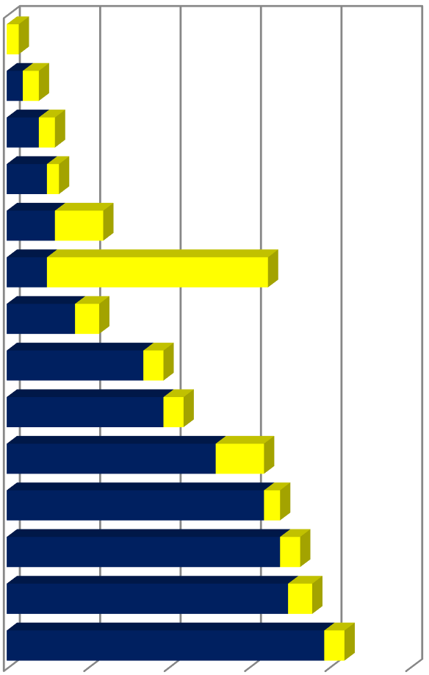

1-

Nov

21-

Nov

Dec

11-

31-

Dec

20-

Jan

9-

Feb

Identify the problem

Do background research

Brainstorm possible solutions

Select a tangible project idea

Proposal Development

E- portfolio development

Initial Design Development

Progress report

Materical Procurment Process

Design Improvement

Final prototype Assembly

Final prototype Testing

E- portfolio and report…

Report Submission

**TASKS TO BE COMPLETED**

Start Date

Days to complete

* 1. Conclusion

In conclusion, our integrated engineering team project aims to address the urgent need for clean and safe drinking water in rural areas of Ethiopia by designing, developing, and testing a low-cost mini water purification device. This mini water purifier container offers a practical and accessible solution for addressing water quality concerns. By utilizing a combination of affordable and easily accessible materials, such as the Arduino Uno, small pH sensor, small LCD display, 12V battery, 5V UV light, polypropylene bottle, peristaltic pump and chemical filters, we can create a compact and efficient system for purifying water. The mini water purifier container provides an opportunity to enhance accessibility to safe drinking water. The mechanical filters, such as sand, gravel media, and charcoal, helps remove physical impurities, while chemical filters, such as acetic acid and sodium, aid in eliminating harmful contaminants. The project's budget allocation of 10,000 ETB demonstrates a practical and cost-effective approach to developing the water purifier container. By carefully selecting materials and leveraging their affordability, the project team can ensure the efficient utilization of resources while maintaining a competitive price point. Overall, the mini water purifier container holds significant potential in addressing water quality challenges, improving access to clean drinking water, and promoting public health and well-being. With proper implementation and continuous refinement, this solution can make a positive impact on communities and individuals affected by water contamination issues. We are committed to the success of this project and believe that our device can make a significant impact in providing safe, affordable drinking water to those in need.

# References

|  |  |
| --- | --- |
| [1] | W. Bolton, "Mechatronics: Electronic Control Systems in Mechanical and Electrical Engineering", 2018. |
| [2] | . J.C. Crittenden, R.R. Trussell, D.W. Hand, K.J. Howe, and G. Tchobanoglous. John Wiley & Sons, 2012., . "Water Treatment: Principles and Design", 2012. |
|  |  |
| [4] | Godfrey C. Onwubolu .Butterworth-Heinemann, , . "Mechatronics: Principles and Applications", 2015. |

## 

# 